Start or Upgrade a Test SDK Project
This guide is to assist ISV partners in setting up their initial Test SDK automated test cases to enable a perfect UI driven simulation of their solution’s use cases. The Test SDK tests can be updated and run against each minor and major release of Acumatica to ensure compatibility with each update and if there is a failure, it will let you know exactly where the failure occurred in the logs.

The start state of each test should be using SalesDemo data, with your customization just published.
Your first test code should be the pre-config steps needed on top of SalesDemo for all your tests to run successfully.
Use test annotations where possible.
Quick Steps to upgrade a test solution:
- Download newest Acumatica installer and TestSDK files
- Configure the old site to the configured start state of the test, then run the new Acumatica installer to upgrade the old site.
- Modify the new Config.xml and the classgenerator.exe.config files
- Update your test project’s command line arguments to use the new config.xml
- Import nuget package from TestSDK download “packages” folder into your solution
- Regenerate wrappers for new version
Setup Guide:
1. Download all the required files
a) Download and install the version of Acumatica you are testing on http://acumatica-builds.s3.amazonaws.com/index.html?prefix=builds/21.2/21.200.0145/AcumaticaERP/
b) Download the matching Test SDK version: http://acumatica-builds.s3.amazonaws.com/index.html?prefix=builds/21.2/21.200.0145/TestSDK
c) Extract the test files to C:\Acumatica2021R2\TestSDK or similar
d) Install .NET framework 4.8 if not already installed: https://dotnet.microsoft.com/en-us/download/dotnet-framework/net48
e) (Optional) Complete Source Code for the project: https://github.com/Acumatica/Test-SDK-Starter-Guide

2. Open Visual Studio and create a new project, Using the Console App (.NET Framework 4.8) C# template. Ensure it is a .NET 4.8 project or you may have issues running the solution.

3. Once the project is created, Right click the project and “Manage Nuget Packages”, Then click the settings icon.

4. Create a new package source, enter a name (recommended to include the Acumatica build number) and use the TestSDK/packages folder we extracted earlier from C:\Acumatica2021R2\TestSDK

5. Ensure the newly created package source is selected.

6. Install the following packages from the nuget package source we just added.
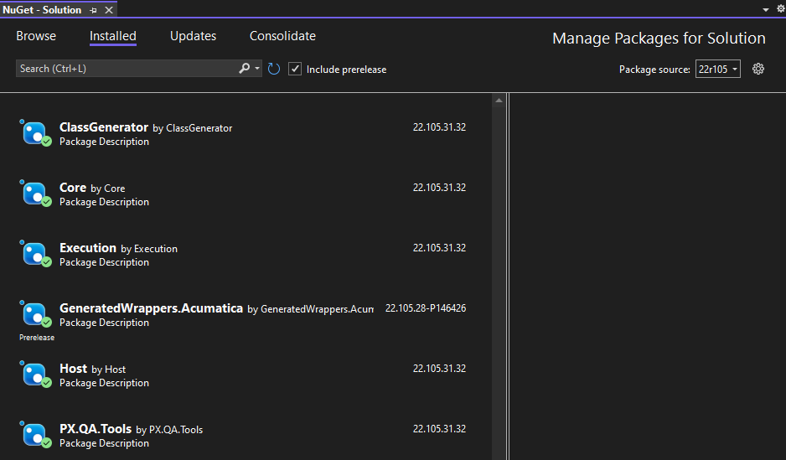

7. Configure the TestSDK config.xml from C:\Acumatica2021R2\TestSDK as below modifying as needed.
<?xml version="1.0" encoding="utf-8"?>
<config>
<general>
<browserbin>C:\TestSDK22r100\Chrome\chrome.exe</browserbin>
<browser_downloads_folder> c:\share\download\</browser_downloads_folder>
<site_dst>
<url>http://localhost/2021r205</url>
<login>admin</login>
<pswd>123</pswd>
</site_dst>
<logging>
<logStorage type="htmlfile" level="INFO" outputFolder="c:\share\logs" screenshotActive="true" />
</logging>
</general>
<testing>
<Check Name="Test.cs file name goes here."/>
</testing>
</config>
8. Create a new folder named “Wrappers” in the project and then generate the wrappers needed for your tests. For more detailed information on Wrapper generation refer to “How to Generate Wrappers” Guide, you must Generate the wrappers for every new or modified screen you use for your tests; Default Acumatica screen wrappers are found inside the GeneratedWrappers.Acumatica Nuget package. Wrappers are Version specific and must be regenerated each time you update Acumatica, Extensions files do not change.
Basic Steps to config and run ClassGenerator.exe
- You must Generate the wrappers for every new or modified screen you use for your tests. Default Acumatica screen wrappers can be found inside the version specific GeneratedWrappers.Acumatica nuget package.
- Go to C:\Acumatica2021R2\TestSDK_21_205\ClassGenerator folder
- Edit ClassGenerator.exe.config (do not modify classgenerator.xml..)
<?xml version="1.0" encoding="utf-8"?>
<configuration>
<appSettings>
<add key="SitePhysicalPath" value="C:\AcumaticaSites\21r205" />
<add key="GenResultPath" value="C:\TestSDK21r205\ClassGenerator\Out" />
<add key="Username" value="admin@Company " />
<add key="Namespace" value="GeneratedWrappers.ISVSOLUTIONNAME" />
<add key="ClearOutput" value="false" />
<add key="FilenameFilter" value="AP303000, SO301000" />
<!--<add key="PagesList" value="list.txt"/>
<add key="PagesListAttribute" value="exclude"/>
<add key="PagesListAttribute" value="include"/>
<add key="PagesParameters" value="ParamsPP.txt"/>
<add key="GenericInquiryParameters" value="ParamsGI.txt"/>-->
</appSettings>
<startup>
<supportedRuntime version="v4.0" sku=".NETFramework,Version=v4.8" />
</startup>
</configuration>
- Ensure you include all new or modified screens you need to use during your test in the FilenameFilter attribute. As well as fill the other attributes with your sites correct information.
- Double click the ClassGenerator folder to start the Wrapper Generation Process
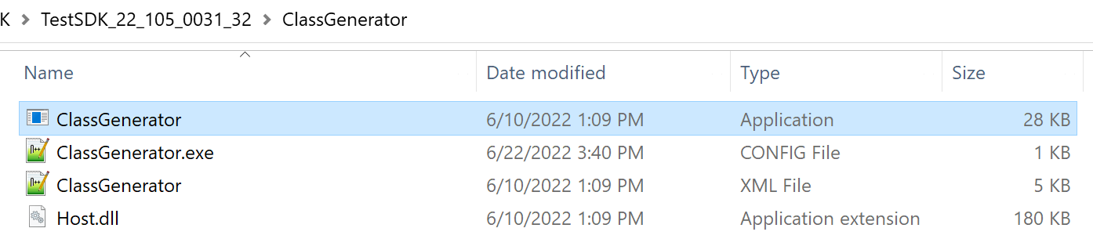
Note: The ClassGenerator.exe command prompt will take 2-5 mins to show progress, don’t worry it is not frozen, just keep waiting for the first screen wrapper to generate then they start going quickly. Do not close the window, the command prompt window must close on its own to complete the process. Closing classgenerator.exe early will break the sites web.config.
- Copy those folders with wrappers inside to the Wrappers folder of your solution
9. Create a second folder for Extensions and create an extension file for every screen used in your tests, extension files do not change between versions. (see “How to Create Extensions” Guide below)
Basic Steps to Create Extensions
a) Create a .cs file in the extensions folder.
b) Right click and Inspect element on the form/button/field you want to use in your test, Copy the label text or element ID of a unique or easily identifiable field you want to access, then take that field name and search the generated wrapper file for the element id or field’s label name
c) Search the name of the ID or label name text in the generated wrapper file
d) Then search for the first use of the class name for that field. Copy the class and class name from the wrapper.
e) Paste those 2 values on the extension file in the format shown below to make it and all other element on the same form accessible in your test. Name it appropriately to use in your test cases, in this case “CreateContactPopupForm”
f) Now that you have created the extensions, you can write the tests using those forms/fields, autocomplete will show you all the fields contained in those form elements.
10. Add the following to the .csproj properties, right click the project -> properties -> Debug :
commandLineArgs": ".\\Tests.exe /config \"C:\\AcumaticaTestSDK\\TestSDK_22_105_0031_32\\config.xml\"
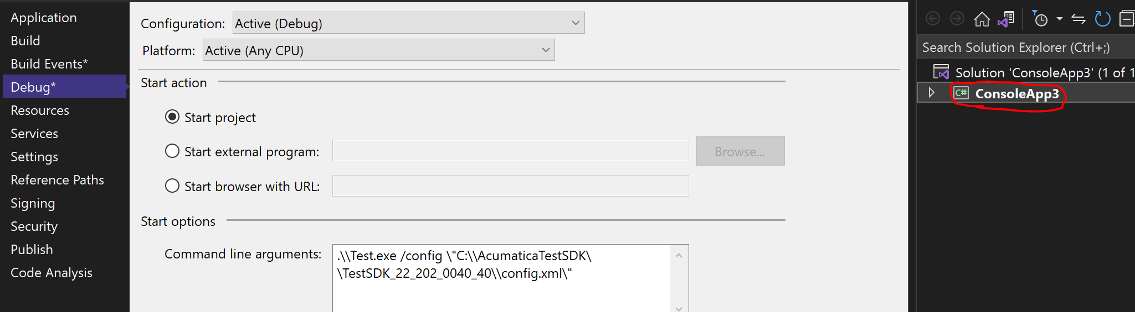

-OR- launchSettings.json of the Test Project so you can simply click run(f5) in visual studio to kick off the tests.cs.
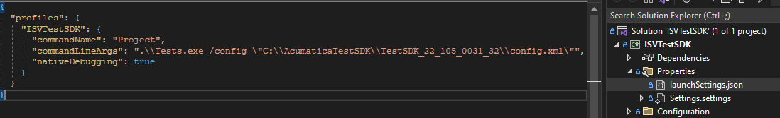

11. After setting the config.xml and application arguments, Run the project, The Acumatica site will pop up and run through the test steps showing the UI as it runs, the first time you run the test it may take 1-10 mins to load all the files before the browser pops up and begins automated testing. Then review the output files in the logging folder location you set in the config files.
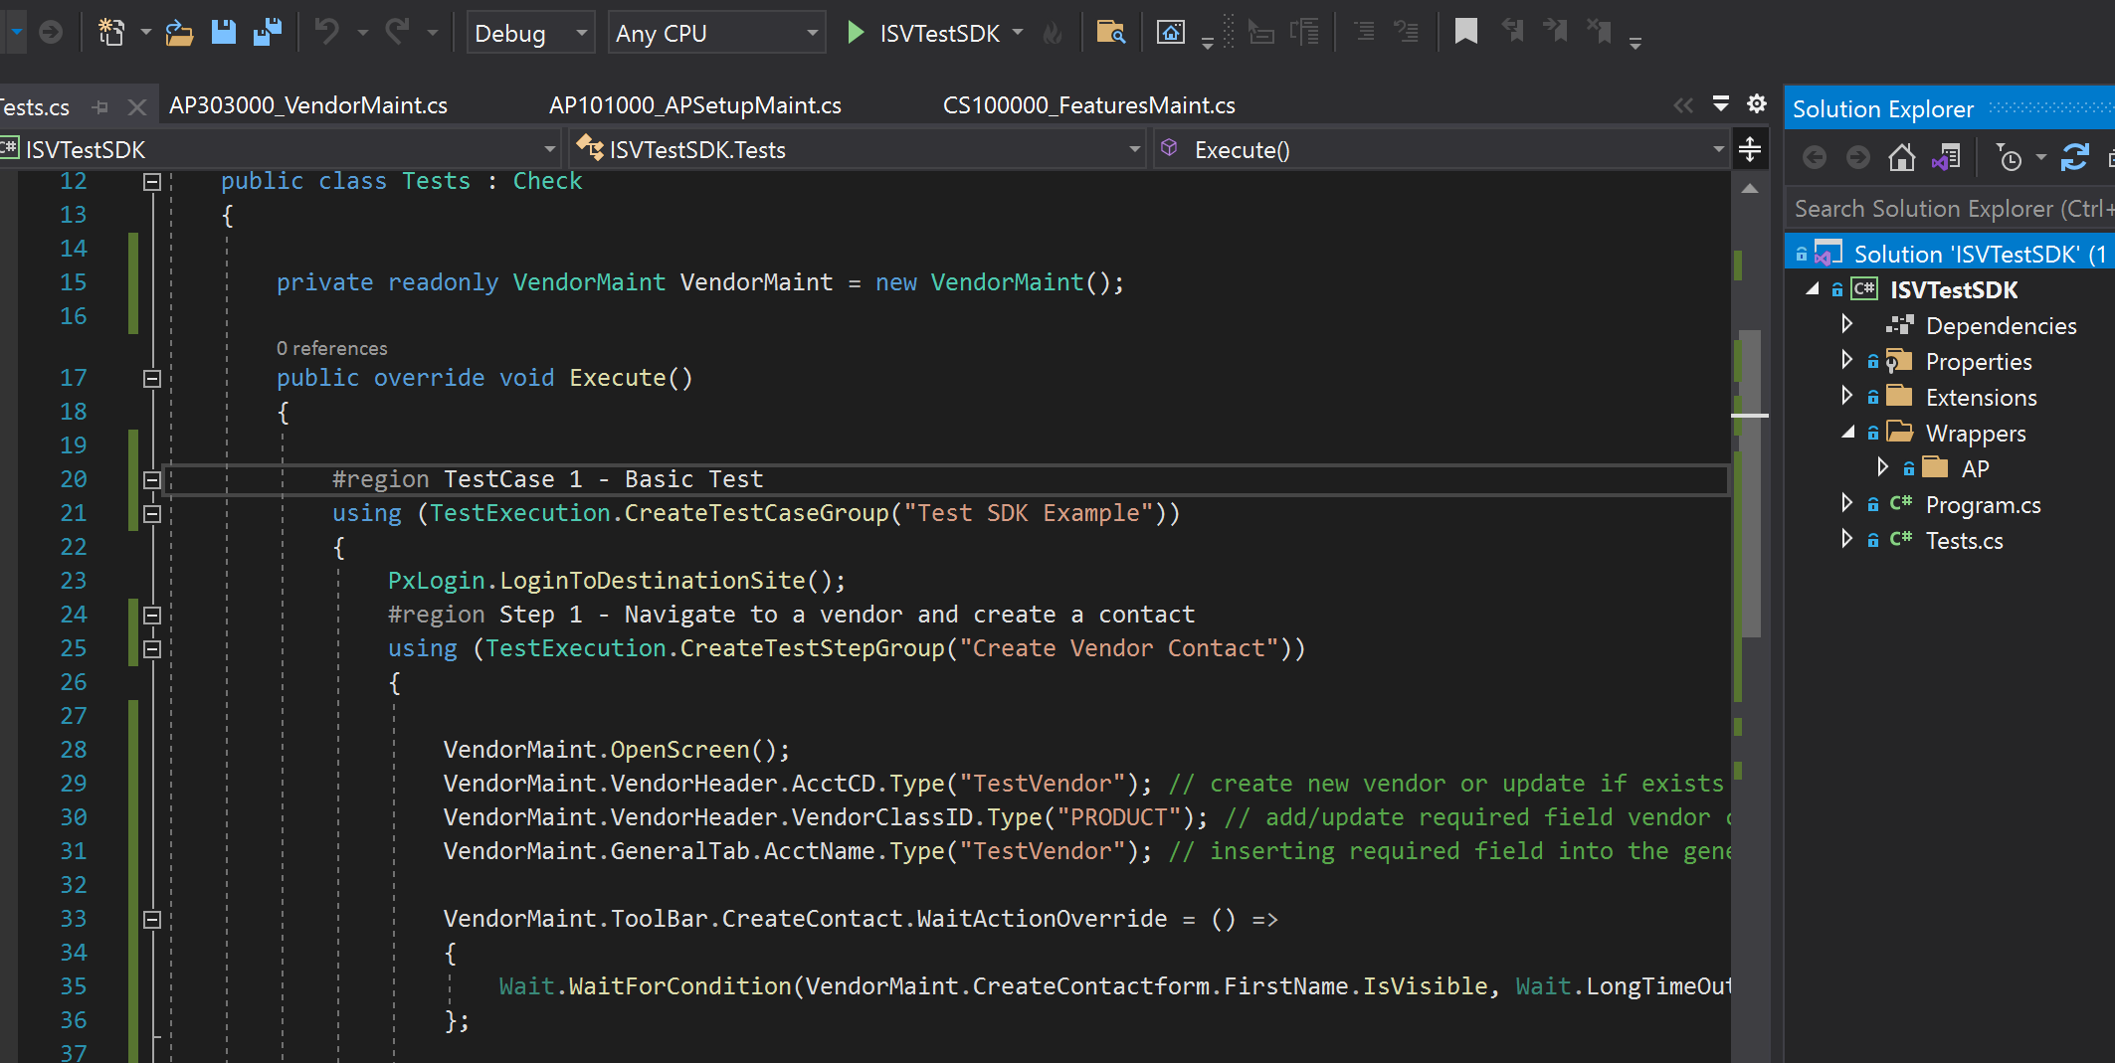

Common Errors:
1) Test exited with Error code 2: Your test has failed, please check the generated log file we configured in step 11
2) Test exited with Error code 0: The test passed successfully.
3) Test exited with Error code 1: Invalid/missing file, likely incorrect folder mapped in the config files somewhere or a missing wrapper/extension
4) Acumatica site no longer accessible after generating wrappers or running a test: The Wrapper Generation process ended without resetting and releasing the web.config.
a) Wait for the Wrapper generation to finish and self close and it will unlock. Do not manually close the classgenerator.exe window.
b) Fix it by copying the original saved web.config that was stored in the website folder as “web.config.63b98fa0” or similar into the web.config file.

